Diseño Esquemático

Diseño Contador de 0-59

Minutos:

Unidades

|  |  |  |  |  |  |  |  |  |  |  |  |  |  |  |  |  |  |  |
| --- | --- | --- | --- | --- | --- | --- | --- | --- | --- | --- | --- | --- | --- | --- | --- | --- | --- | --- |
|  | Q3 | Q2 | Q1 | Q0 |  | Q3 | Q2 | Q1 | Q0 |  | J3 | K3 | J2 | K2 | J1 | K1 | J0 | K0 |
| 0 | 0 | 0 | 0 | 0 |  | 0 | 0 | 0 | 1 |  | 0 | X | 0 | X | 0 | X | 1 | X |
| 1 | 0 | 0 | 0 | 1 |  | 0 | 0 | 1 | 0 |  | 0 | X | 0 | X | 1 | X | X | 1 |
| 2 | 0 | 0 | 1 | 0 |  | 0 | 0 | 1 | 1 |  | 0 | X | 0 | X | X | 0 | 1 | X |
| 3 | 0 | 0 | 1 | 1 |  | 0 | 1 | 0 | 0 |  | 0 | X | 1 | X | X | 1 | X | 1 |
| 4 | 0 | 1 | 0 | 0 |  | 0 | 1 | 0 | 1 |  | 0 | X | X | 0 | 0 | X | 1 | X |
| 5 | 0 | 1 | 0 | 1 |  | 0 | 1 | 1 | 0 |  | 0 | X | X | 0 | 1 | X | X | 1 |
| 6 | 0 | 1 | 1 | 0 |  | 0 | 1 | 1 | 1 |  | 0 | X | X | 0 | X | 0 | 1 | X |
| 7 | 0 | 1 | 1 | 1 |  | 1 | 0 | 0 | 0 |  | 1 | X | X | 1 | X | 1 | X | 1 |
| 8 | 1 | 0 | 0 | 0 |  | 1 | 0 | 0 | 1 |  | X | 0 | 0 | X | 0 | X | 1 | X |
| 9 | 1 | 0 | 0 | 1 |  | 0 | 0 | 0 | 0 |  | X | 1 | 0 | X | 0 | X | X | 1 |

J3= Q2 Q1 Q0

K3= Q0

J2= Q0 Q1

K2=Q0 Q1

J1= Q3N Q0

K1=Q0

J0= 1

K0=1

ENABLE DE DECIMAS

en = (Q0 and Q1N AND Q2N AND Q3)

|  |  |  |  |  |  |  |  |  |  |  |  |  |  |  |  |  |  |  |
| --- | --- | --- | --- | --- | --- | --- | --- | --- | --- | --- | --- | --- | --- | --- | --- | --- | --- | --- |
|  | Q3 | Q2 | Q1 | Q0 |  | Q3 | Q2 | Q1 | Q0 |  | J3 | K3 | J2 | K2 | J1 | K1 | J0 | K0 |
| 0 | 0 | 0 | 0 | 0 |  | 0 | 0 | 0 | 1 |  | 0 | X | 0 | X | 0 | X | 1 | X |
| 1 | 0 | 0 | 0 | 1 |  | 0 | 0 | 1 | 0 |  | 0 | X | 0 | X | 1 | X | X | 1 |
| 2 | 0 | 0 | 1 | 0 |  | 0 | 0 | 1 | 1 |  | 0 | X | 0 | X | X | 0 | 1 | X |
| 3 | 0 | 0 | 1 | 1 |  | 0 | 1 | 0 | 0 |  | 0 | X | 1 | X | X | 1 | X | 1 |
| 4 | 0 | 1 | 0 | 0 |  | 0 | 1 | 0 | 1 |  | 0 | X | X | 0 | 0 | X | 1 | X |
| 5 | 0 | 1 | 0 | 1 |  | 0 | 0 | 0 | 0 |  | 0 | X | X | 1 | 0 | X | X | 1 |

J3= 0

K3= 1

J2= Q1Q0

K2=Q0

J1=Q2’Q0

K1=Q0

J0= 1

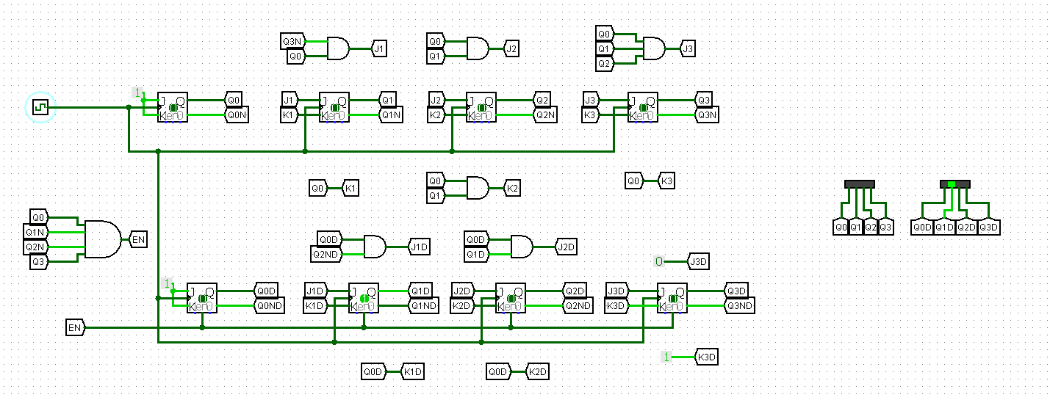K0=1

Enable de Horas

De unidades = (Q0 and Q1N AND Q2N AND Q3)

AND

De decimas = (Q0 and Q1N AND Q2 AND Q3N)

|  |  |  |  |  |  |  |  |  |  |  |  |  |  |  |  |  |  |  |  |  |  |  |
| --- | --- | --- | --- | --- | --- | --- | --- | --- | --- | --- | --- | --- | --- | --- | --- | --- | --- | --- | --- | --- | --- | --- |
|  | E | Q3 | Q2 | Q1 | Q0 |  | E | Q3 | Q2 | Q1 | Q0 |  | JE | KE | J3 | K3 | J2 | K2 | J1 | K1 | J0 | K0 |
| 0 | 0 | 0 | 0 | 0 | 0 |  | 0 | 0 | 0 | 0 | 1 |  | 0 | X | 0 | X | 0 | X | 0 | X | 1 | X |
| 1 | 0 | 0 | 0 | 0 | 1 |  | 0 | 0 | 0 | 1 | 0 |  | 0 | X | 0 | X | 0 | X | 1 | X | X | 1 |
| 2 | 0 | 0 | 0 | 1 | 0 |  | 0 | 0 | 0 | 1 | 1 |  | 0 | X | 0 | X | 0 | X | X | 0 | 1 | X |
| 3 | 0 | 0 | 0 | 1 | 1 |  | 0 | 0 | 1 | 0 | 0 |  | 0 | X | 0 | X | 1 | X | X | 1 | X | 1 |
| 4 | 0 | 0 | 1 | 0 | 0 |  | 0 | 0 | 1 | 0 | 1 |  | 0 | X | 0 | X | X | 0 | 0 | X | 1 | X |
| 5 | 0 | 0 | 1 | 0 | 1 |  | 0 | 0 | 1 | 1 | 0 |  | 0 | X | 0 | X | X | 0 | 1 | X | X | 1 |
| 6 | 0 | 0 | 1 | 1 | 0 |  | 0 | 0 | 1 | 1 | 1 |  | 0 | X | 0 | X | X | 0 | X | 0 | 1 | X |
| 7 | 0 | 0 | 1 | 1 | 1 |  | 0 | 1 | 0 | 0 | 0 |  | 0 | X | 1 | X | X | 1 | X | 1 | X | 1 |
| 8 | 0 | 1 | 0 | 0 | 0 |  | 0 | 1 | 0 | 0 | 1 |  | 0 | X | X | 0 | 0 | X | 0 | X | 1 | X |
| 9 | 0 | 1 | 0 | 0 | 1 |  | 1 | 0 | 0 | 0 | 0 |  | 1 | X | X | 1 | 0 | X | 0 | X | X | 1 |
| X | X | X | X | X | X |  | X | X | X | X | X |  | X | X | X | X | X | X | X | X | X | X |
| 16 | 1 | 0 | 0 | 0 | 0 |  | 1 | 0 | 0 | 0 | 1 |  | X | 0 | 0 | X | 0 | X | 0 | X | 1 | X |
| 17 | 1 | 0 | 0 | 0 | 1 |  | 1 | 0 | 0 | 1 | 0 |  | X | 0 | 0 | X | 0 | X | 1 | X | X | 1 |
| 18 | 1 | 0 | 0 | 1 | 0 |  | 0 | 0 | 0 | 0 | 1 |  | X | 1 | 0 | X | 0 | X | X | 1 | 1 | X |
| X | X | X | X | X | X |  | X | X | X | X | X |  | X | X | X | X | X | X | X | X | X | X |

Horas:

JE=Q3 Q0

KE=Q1

J3= Q2 Q1 Q0

K3= Q0

J2= Q1Q0

K2=Q1Q0

J1=Q3N Q0

K1=QE + Q0

J0= 1

K0=1

Nota el estado 0000 solo es para iniciación y una vez que empiece no el reloj digital no volverá a 000

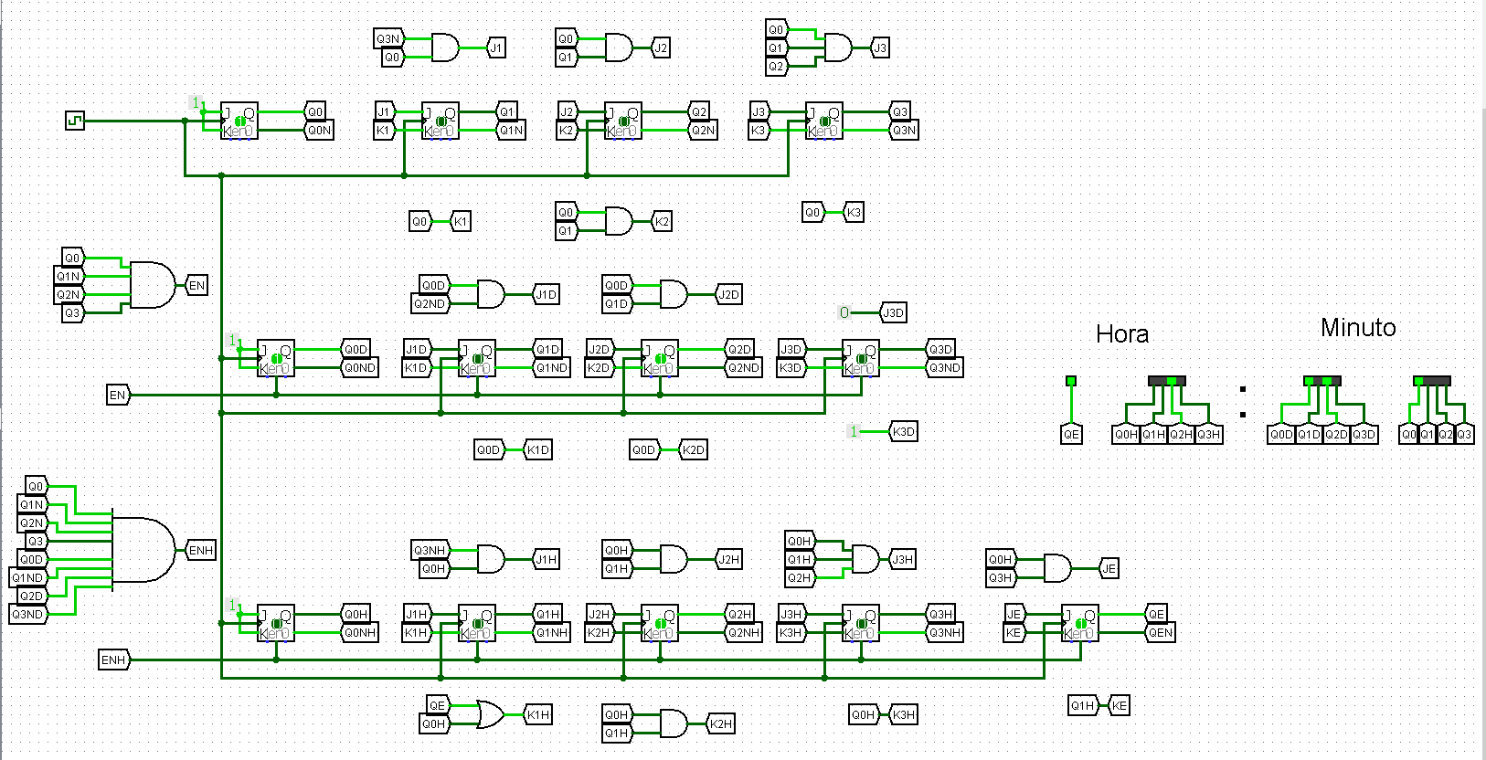Final